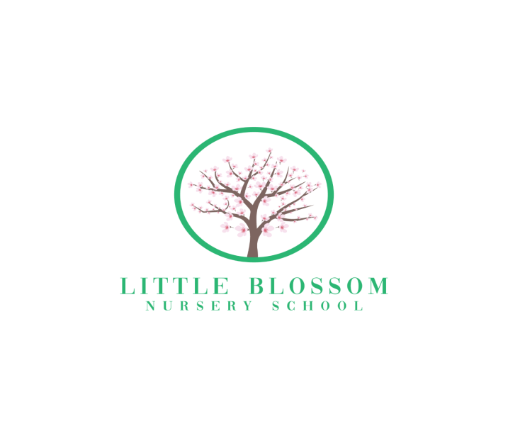

**Registration Form**

**OFSTED Registration 2740063**

**Leavesden Green Community Hub**

**Clarke Green (Off Clarke Way)**

**Watford**

**WD25 0BW**

**Child's Name:**

**Name Child is known by, if different**

**D.O.B:**

**Home Address:**

**Telephone Number:**

**Names of Parents and place of work: (and contact numbers)**

**Mother:**

**Telephone**

**Mobile:**

**Email:**

**Father:**

**Telephone Number:**

**Mobile:**

**Email**

**Other emergency contact:(if parents unavailable)**

**Dr's Name:**

**Telephone no:**

**Address:**

**Immunisations: Polio Whooping Cough MMR**

**Tetanus Meningitis BCG HIB**

**Any known Medical Conditions:**

**____________________________________________________________________________________________________________________________________________**

**Any known allergies etc.:**

**Any other relevant information: (e.g.: Religious or cultural requirements) ________________________**

**Any dietary requirements including things they may NOT eat. (for example, nuts, eggs, dairy products, Treats (these are only allowed on special occasions)**

**Is there anything your child particularly likes to eat or absolutely refuses to eat?**

**Does your child have any special toys/comforters?**

**or “special” family words or names for things or people?**

**_____**

**Is your child potty Trained?**

**__________________________________________________________________________________________________________________________________________________________________________________________________________________**

The offer of a place at Little Blossom Nursery School is subject to availability and you will receive a confirmation letter that your child has been allocated a place. Returning this form does not guarantee your child a place, therefore we recommend early registration to avoid disappointment.

Little Blossom Nursery School charges a non-refundable registration fee of £50 which should be included with this form. Please make your cheque payable to Little Blossom Nursery School.

**Parental Responsibility**

The Early Years Foundation Stage Framework Statutory Requirement ‘Safeguarding and promoting children’s welfare’ states that childcare providers must obtain ‘information about who has legal contact with the child and who has parental responsibility’.

( For guidance on what parental responsibility means see pages in Policies and Procedures.)

I therefore require all parents/carers to complete the form below, prior to their child being admitted into my care. If there are any subsequent changes to these details please let me know immediately

Name of Child

Date of Birth

**Parent/Carer 1**

Name

Relationship

Legal contact yes/no

Parental responsibility yes/no

**Parent/Carer 2**

Name

Relationship

Legal contact yes/no

Parental responsibility yes/no

**Safeguarding Children Statement**

I understand that as a registered Nursery School, **Little Blossom Nursery School** has a duty to safeguard any child entrusted to her care and to discuss any concerns about the child with the parent / carer unless it places the child, Little Blossom Staff or another child at further risk.

If it is apparent that her concerns deserve further investigation, she is obliged to refer the situation to the Nominated Safeguarding Children Officer of the local authority Children’s Services covering the area in which the child lives and to inform the relevant authority responsible for our registration. (Ofsted).

I also understand that it may become necessary for Little Blossoms to disclose confidential information, and that this will be the minimum strictly necessary to protect the health and wellbeing of the child.

I understand I can refuse to consent to this information being disclosed.

I have read and understood this statement and the need for it.

Signed

Date____________________________________

**Permission to apply sunscreen.**

I give permission to apply the sunscreen I have provided to my child.

Signed: ……………………………………………………………………….

Name(s) of Child:……………….…………………………………………….

Date: ……………………………………………………………………………

**Permission to allow observations of my child**

I give permission for Little Blossom staff to observe my child and to produce a written observation for the purposes of her training and for sharing with myself.

Signed …………………………………………………..

Date………………………..

Name of Child………………………………………………………………………….

**Permission to take Photographs**

I give permission for Little Blossom Staff to take photographs of my child and to use them for display in the nursery, EYFS observations, website, promotional material, social media accounts and any training assignments. I understand that for the training assignments my child will remain anonymous.

Signed …………………………………………………………………………….

Date………………………………………………………………………………..

Name of Child…………………………………………………………………….

**Permission to seek emergency medical assistance/treatment.**

I give permission for Little Blossom staff to seek EMERGENCY medical assistance/treatment for my child:

(Child's name)

Signed (Parent)

Date

**Permission to allow my child to go on local outings.**

I give permission for **Little Blossom Staff** to take my child out on local outings, including the use of the personal business registered car and public transport. I understand that should she wish to take my child on an outing further away she will write to me, and I will be asked to sign an additional permission form.

Signed: ……………………………………………………………………….

Name(s) of Child:……………….…………………………………………….

Date: ……………………………………………………………………………

**Permission to share information.**

I give permission for Little Blossom Staff**,** to share information with my child’s school/nursery/pre-school.

**Child’s name**

**Name of school/nursery/pre-school**

I understand that this is partnership working, which is in line with the Early Years Foundation Stage Framework, and wish my child to receive continuity of care between settings.

**Signed**

**Name**

**Date**

**Parental confirmation**

This is to confirm that I have read and understood the policies and procedures given to me by **Laura Scales.**

I also confirm I have read and signed the relevant permission forms.

Signed __________________________________________

Date_____________________________________________

**Permission to apply Plasters.**

I give permission for **Little Blossom Staff** to use a plaster should my child need one.

Signed: ……………………………………………………………………….

Name(s) of Child:……………….…………………………………………….

Date: …………………………………………………………………………

GDPR Permission Form

I give permission for the Little Blossom Staff to collect and process non-statutory information about my child such as the name of my child’s GP, interests, likes and dislikes etc, as well as sensitive classes of information including your child’s racial or ethnic origin, religious or other beliefs, and physical or mental health details. This information will be kept confidential.

Signed: ……………………………………………………………………….

Name(s) of Child:……………….…………………………………………….

Date: ……………………………………………………………………………

**Tapestry Online Learning Journey Online Consent Form**

Dear all,

We are really excited to be introducing an online Learning Journey provided by Tapestry and the Early Years Foundation Stage Forum. It allows us to upload photographs, videos and observations to an online account which you will then have access to using your email address and secure password. It is the same system now used by the various nurserys and pre schools in the area. The system is hosted in the UK and managed by a central security team. The safeguarding of the children I, as always, very important to us and the information will be added to our setting account and can only be viewed by staff via a secure login and yourself.

It is only you who has access to your child's account and this cannot be seen by other parents. As this is an online profile, we will need your permission to set up your child’s account. Please rest assured that the information about your child and their learning is secure and is only accessible by the members of staff and yourselves as parents. Any personal details about your child are confidential and will not be disclosed. There may also be instances where your child appears in a photograph documenting another child’s learning, as they currently are in the paper learning journeys.

The photos and videos uploaded to Tapestry by staff at the setting remain the property of Little Blossom Nursery School and you do not have permission to upload them onto any website. Any instances where this confidentiality is broken will be dealt with very seriously and will result in your access to the system being withdrawn.

We are very keen to engage every parent in their child’s learning and progress throughout the year and we welcome any observations and photographs you may make of your own. This can be uploaded by yourself and we can view them and the children can share their experience with their friends.

More information can be found at <http://eyfs.info/tapestry-info/introduction>

Any questions at all please do give me a shout

Kind regards,

Kellie Middleton

Nursery Manager

**Tapestry Online Learning Journey Permission**

**Please complete the following permission slip.**

**You will be given details of your login details when this is returned to school to be kept in your child’s records.**

**Failure to abide with Number 4 will result in your child’s Online Learning Journey being suspended.**

**Child’s Name .........................................................**

1. I give permission for my child to have a Tapestry Online Learning Journey created and maintained.
2. I give permission for staff to take photographs and videos of my child to be used in their online learning journal
3. I give my permission for my child to appear in any group photos used in the learning journal. I understand that my child's image will be view-able by all parents/ carers of the pupils featured in that particular photo.
4. I agree NEVER to post any content from my child’s learning journey on any social networking site, e.g. Facebook. Or other Platforms. I understand that my child’s Learning Journey is to be used for my own personal use.
5. I agree to keep my login details safe and secure
6. I agree for photos to be used as follows

Nursery Website

Nursery Social Media

Internal Nursery Displays

Email address I would like to use to access my child’s Tapestry Account is

______________________________________________

**Parent/ Carers Signature**

**...................................................**

**Please print name**

**------------------------------------**

**Date ............................................**