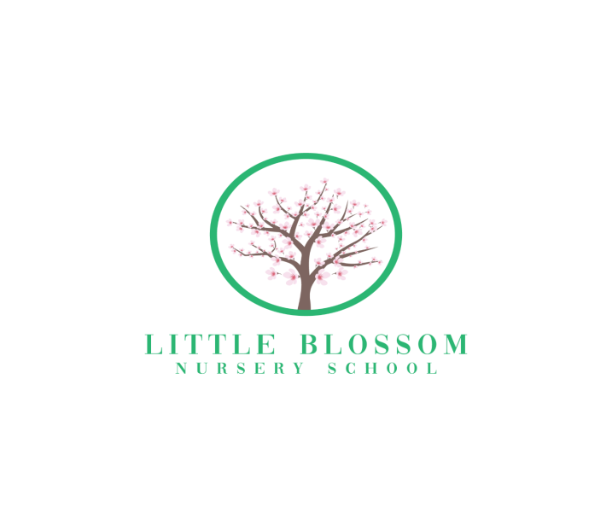

**Registration Form**

**OFSTED Registration 2701350**

**Luther Blissett Community Hub**

**Brocklesbury Close**

**Watford**

**WD24 4HY**

**Child's Name:**

**Name Child is known by, if different**

**D.O.B:**

**Home Address:**

**Telephone Number:**

**Names of Parents and place of work: (and contact numbers)**

**Mother:**

**Telephone**

**Mobile:**

**Email:**

**Father:**

**Telephone Number:**

**Mobile:**

**Email**

**Other emergency contact:(if parents unavailable)**

**Dr's Name:**

**Telephone no:**

**Address:**

**Immunisations: Polio Whooping Cough MMR**

**Tetanus Meningitis BCG HIB**

**Any known Medical Conditions:**

**____________________________________________________________________________________________________________________________________________**

**Any known allergies etc.:**

**Any other relevant information: (e.g.: Religious or cultural requirements) ________________________**

**Any dietary requirements including things they may NOT eat. (for example, nuts, eggs, dairy products, Treats (these are only allowed on special occasions)**

**Is there anything your child particularly likes to eat or absolutely refuses to eat?**

**Does your child have any special toys/comforters?**

**or “special” family words or names for things or people?**

**_____**

**Is your child potty Trained?**

**__________________________________________________________________________________________________________________________________________________________________________________________________________________**

The offer of a place at Little Blossom Nursery School is subject to availability and you will receive a confirmation letter that your child has been allocated a place. Returning this form does not guarantee your child a place, therefore we recommend early registration to avoid disappointment.

Little Blossom Nursery School charges a non-refundable registration fee of £50 which should be included with this form. Please make your cheque payable to Little Blossom Nursery School.